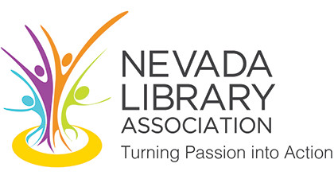
NEVADA LIBRARY ASSOCIATION
NOMINATION CONSENT FORM

Name: |  |  | Title:
Organization: |  |  | City/State:
Phone: |  |  | Email:
In order to be considered for a Nevada Library Association office by the NLA Nominating Committee, we must receive your written consent before your name can be placed on the slate of candidates.
I hereby give my consent for my name to be placed in nomination for the NLA office of:
I am currently a member of NLA: |  | Yes No (double click to select checked)

Please write a brief biographical summary (150 words or less) of your personal credentials, experience, awards, previous offices, etc.:

Please write a short statement (50 words or less) about what you hope to accomplish for or contribute to NLA in this position:

Signature (for digital signature, please print full name): Date:

Nomination Forms must be submitted by email or fax to the Elections Committee Chairman, Tam Anderson, by December 3rd, 2017.

Tam Anderson, Elections Committee Chairman
Las Vegas-Clark County Library District: Rainbow Library
3150 N. Buffalo Dr., Las Vegas, NV 89128
Phone: 702-507-3512 | Fax: 702-507-3730 | Email: Andersont@lvccld.org

